1. Find the domain of the function 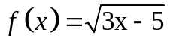
2. Suppose that the graph of is given. Describe how the graph
of the function can be obtained from the graph of .
a. | Shift the graph 5 units to the right and 6 units down
b. | Shift the graph 5 units to the left and 6 units down
c. | Shift the graph 5 units to the left and 6 units up
d. | Shift the graph 5 units to the right and 6 units up
3. Find 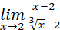
4. For what values of c is the function 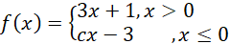
continuous on ?
5. The graph of a function f is shown, find: 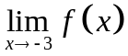 .
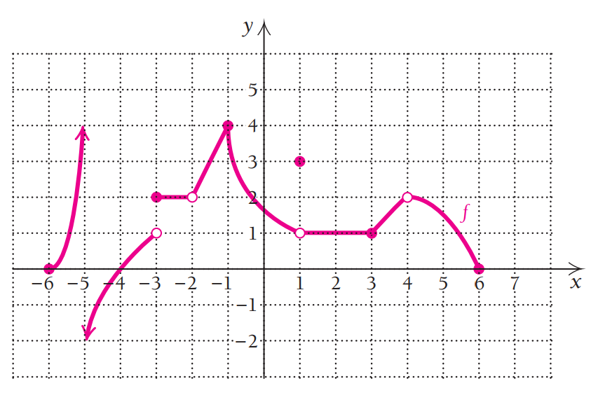
6. State the numbers at which is not differentiable
7. A table of values for f,g,f ',g' is given
x | 0 | -1 | 2
f(x) | 1 | -2 | -4
f '(x) | 2 | -1 | 2
g(x) | 1 | 2 | -1
g'(x) | -2 | -1 | -2
Find h'(2) if h(x)=f(g(x))
8. For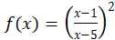. Find
9. Find by implicit differentiation if

10. Find the linear approximation for at .
11. Suppose that.
Find the number c in Rolle's theorem
12. Use Newton’s Method with initial approximation x₁=1 to find x₃, the third approximation to the root of the equation x³+3x=5. What is the result?
13. Find the general anti-derivative of the function
14. Suppose and for all x. How large can f(5) possible be?
15. Find two positive numbers whose product is 225 and whose sum is a minimum.
16. A particle moves along a line so that its velocity at time t is (measured in meters per second). Find the displacement of the particle during the time.
17. Suppose 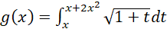. What is ?

18. Find the average value of the function on the interval [-2,3].
19. Suppose f is a function such that:
Find 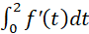
20. Evaluate 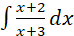
21. Find all points of intersection of the plane 3x+5y-2z + 1=0 and the line
(x,y,z)=(-1,2,3)+t(-3,5,1)
22. Find the equation of the plane through P(1,2,0), Q(5,3,1) and R(2,-3,1)

23. If u=(2,-1,1) and v=(1,x,2) are at an angle of , then x is
24. Find the distance between u=(-1,2,3) and v=(2,-2,3).
25. Find the angle between u = (-2,1,5) and v=(3,-2,1).
26. A table of values for f is given:
x | 1 | 2 | 3 | 4 | 5 | 6 | 7
f(x) | 5 | 6 | 3 | 2 | 1 | 4 | 8
Estimate the area under the graph of using three approximating rectangles
and taking the sample points to be right endpoint.
27. Find all points of intersection of the plane 4x+9y-z=20 and the line
(x,y,z)=(5,-2,1)+t(4,0,-1)
28. Find the equation of the plane through P(1,-2,0), Q(1,5,1) and R(4,-1,2)
29. If u=(2,-x,3) and v=(x,1,-2) are at an angle of , then x is…
30. The distance between u=(3,9,2) and v=(3,-2,4) is
31. Find a, b and c so that the system 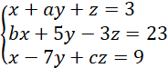 has the solution .
32. Compute the rank of the matrix 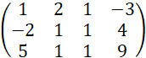
33. Determine the values of k so that the system of equations
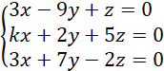
has a unique solution.
34. Determine the values of k such that the system of linear equations is consistent
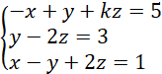
35. Let 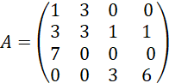.
If is the augmented matrix of a system of linear equations. Solve the system.
36. Find (5v - 3w)•(3v + 2w) if and v•w = -4.
37. The (1, 2)-cofactor of the matrix 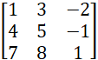 is:
38. Suppose A is a 6x6 matrix with determinant -2. Find det(-5A⁻¹)
39. What is the determinant of the matrix 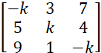 ?
40. What is the characteristic polynomial of the matrix 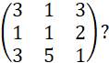
41. Find the eigenvalues of 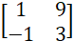.
42. For what values of a is the set of vectors
S={(4,-2,a),(1,-2,7),(9,1,3)} linearly independent?
43. Which of the following are subspaces of R³?
(i) {(a²,b-a, a+2b)|a,b∈R}
(ii) {(a+b+3,a+3b,2a-b)|a,b∈R}
44. Let . Find
45. Let and .
Determine the value of m such that .
46. Let u,v∈R³ such that |u|=4, |v| =3 and u.v=-5. Find (3u+2v)².
47. Find the inverse of the matrix 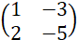
48. If an n×n matrix A satisfies, find A⁻¹.
49. Let be a linear transformation, and assume that
and. Compute
50. Find when 